**Analyzing If Liverpool or Manchester Is Better for Opening a German Restaurant**

**INTRODUCTION**

* 1. **Problem**: A restaurant owner who specializes in German food has found success in London and is looking to expand to a new location. After researching several locations in England, the owner has it narrowed down to two northern cities: Liverpool and Manchester. The owner requests further analysis to determine the best location for his new restaurant.
  2. **Background:** Liverpool and Manchester are two northern cities which thrived during the Industrial Revolution of the 19th centuries, and whose rivalry continues today. Now in the 21st century, both cities have undergone regeneration projects and have become attractive destinations for tourists. Liverpool is a port city located on Liverpool Bay, part of the Irish Sea, and its metropolitan area is the fifth largest in the United Kingdom. Due to its location near water, it has a diverse population with a wide range of cultures. It was named the 2008 European Capital of Culture and ranks seventh on the list of most visited cities in the UK. Liverpool Maritime Mercantile City was designated a World Heritage Site in 2004 by UNESCO and this status, along with the city’s Premier League football clubs, museums and art galleries attracts many tourists each year. Manchester is the third-most populous metropolitan area in the United Kingdom and lies between the Pennines mountain chain and the Cheshire Plain. It is the third most visited city in the UK and is known for its music scene, sports and its variety of architectural style throughout the city. Both cities have a wide range of restaurants that specialize in a variety of foods. [1,2]
  3. **Interests:** This analysis would be useful for restaurant owners trying to decide where to open their next restaurant and could be expanded to include other cities as well. Tourists may also be interested as the analysis could help them be aware of the different types of restaurants that are available in a city which may also impact the hotel they choose depending on where the restaurants are clustered.

**DATA ACQUISITION**

2.1. **Data Sources**: Both Liverpool and Manchester neighborhoods and postal codes were scraped from Wikipedia Tables using BeautifulSoup.[3,4] Restaurant venues for both Liverpool and Manchester were obtained from Foursquare API.

2.2. **Data Cleaning:** After the Wikipedia Tables were scraped, columns that were not needed for the analysis and postal codes that did not correspond to a geographic location or were duplicates of another postal code location were dropped. Once the data was cleaned, the table for each city included the Postcode District and the corresponding Neighborhoods.

**Liverpool City Data**

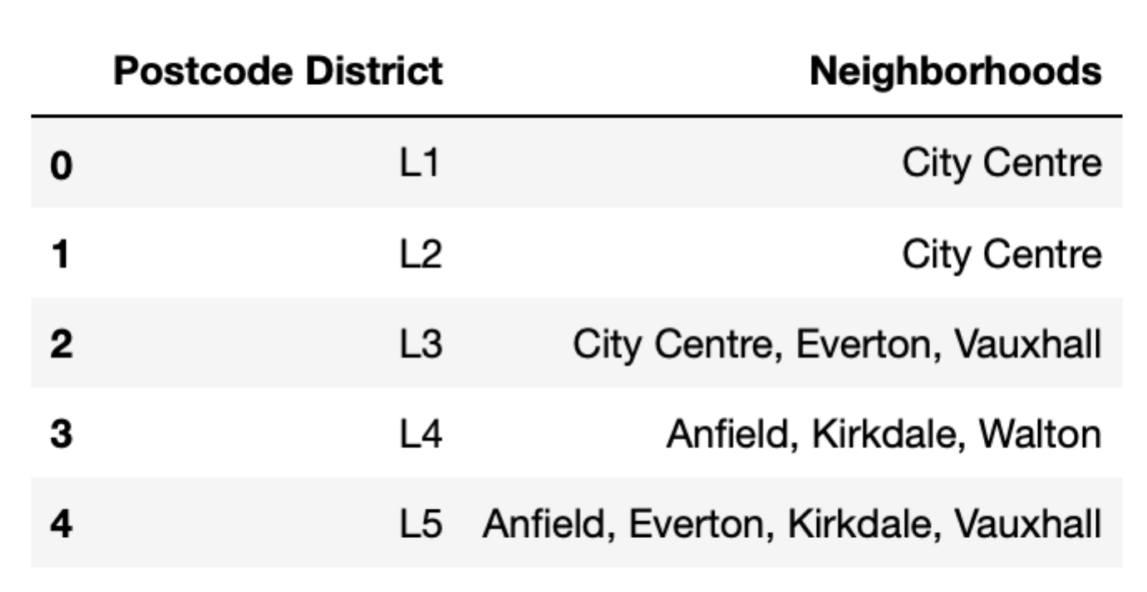

**Figure 1:** Liverpool Postcode District and Neighborhood Data for the first five postcodes in the table.

Liverpool’s dataset include 40 postcode districts while Manchester’s included 43 postcode districts. Using Geocoder, coordinates for the Liverpool neighborhoods and Manchester neighborhoods were added to the corresponding datasets.

**Liverpool City Data**

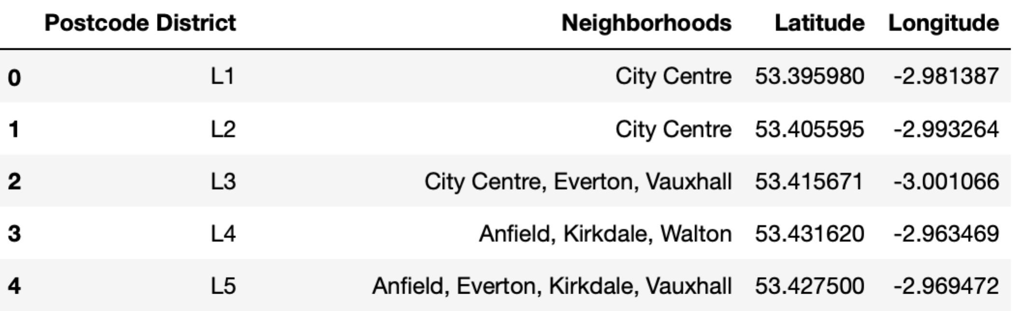

**Figure 2:** Liverpool Final Data Set, which includes Latitude and Longitude, for the first five postcodes in the table.

The Foursquare Venue Data was narrowed down to include restaurants only, and a table for each city was created containing the Neighborhood with latitude and longitude, the venue with latitude and longitude, the venue ID and the venue category.

**Liverpool Venue Data**

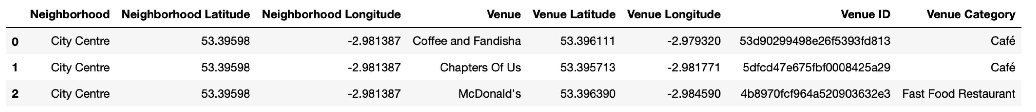

**Figure 3:** Liverpool Venue data set of the first three venues in the table.

This data will be used to determine the best location for the restaurant owner to build his new restaurant by analyzing types of restaurants, clustering of restaurants and location of restaurants in Manchester and Liverpool.

**METHODOLOGY**

3.1. **Comparing Restaurant Diversity**: Using the restaurant venue data pulled from FourSquare for Manchester and Liverpool, a bar graph was created for each city showing the diversity of restaurants. The restaurants were grouped by type of restaurant then plotted on the bar charts.

**3.2. Clustering:** Using one-hot encoding, the restaurants for each city were grouped by type of restaurant and neighborhood in the city. A table was then created for each city showing the top 7 venues in each neighborhood. The elbow method was used on the both the Manchester and Liverpool dataframes to determine the optimal k for clustering the neighborhoods within each city.

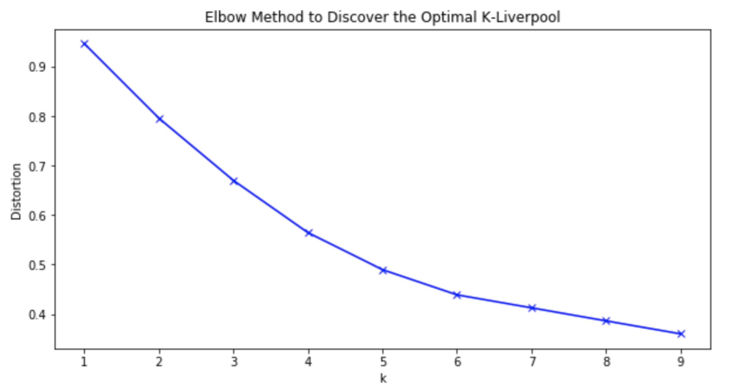

**Figure 6:** The elbow method for Liverpool Neighborhoods showing 5 as the optimal K.

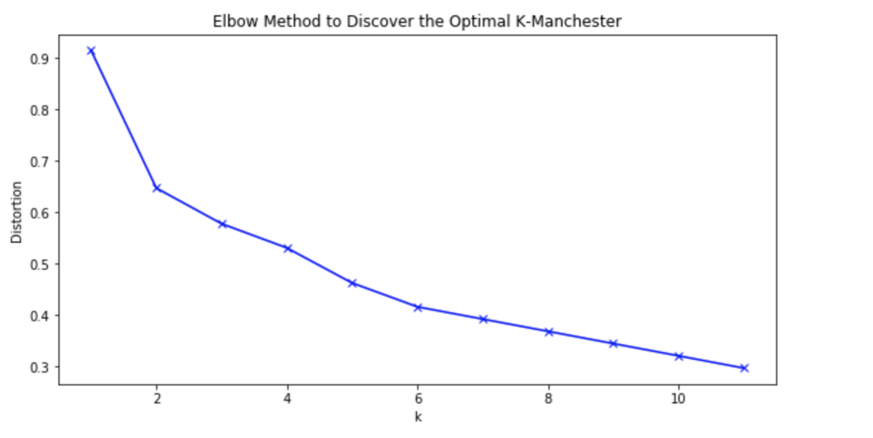

**Figure 6:** The elbow method for Manchester Neighborhoods showing 4 as the optimal K

For Liverpool the optimal K was determined to be five and for Manchester the optimal K was 4. After reviewing the tables for each cluster to discover the top venues, a map was created for each city using folium and color-coded markers were placed for each neighborhood depicting, which cluster it belonged to. A bar chart was also created showing the number of neighborhoods in each cluster.

**RESULTS**

**4.1.** **Liverpool Results:** The top three food venues in Liverpool were coffee shops, cafés and “Restaurants, which can be seen in Figure 7. Within the top twenty food venues, there were seven restaurants with cuisines from different areas of the world including Italian, Chinese, Asian and Portuguese.

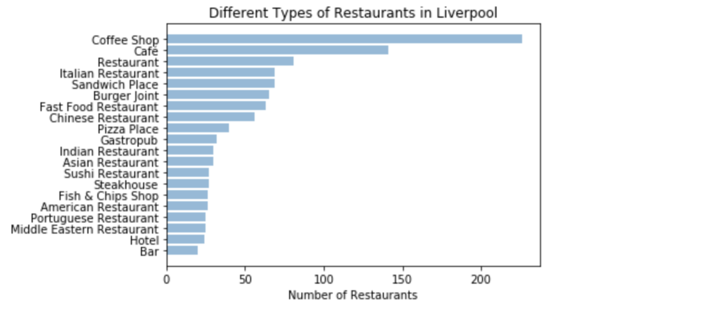

**Figure 7:** A graph depicting the variety of restaurants found in Liverpool.

After the Liverpool data was clustered using k-mean clustering, five separate clusters were discovered within Liverpool. Cluster Zero was where the majority of restaurants offering food from a variety of cultures were located. Cluster One’s top food venue was coffee shops, Cluster Two was café’s, Cluster Three were non-descriptive restaurants and wine bars and lastly Cluster Four was the Chinese Restaurant cluster.

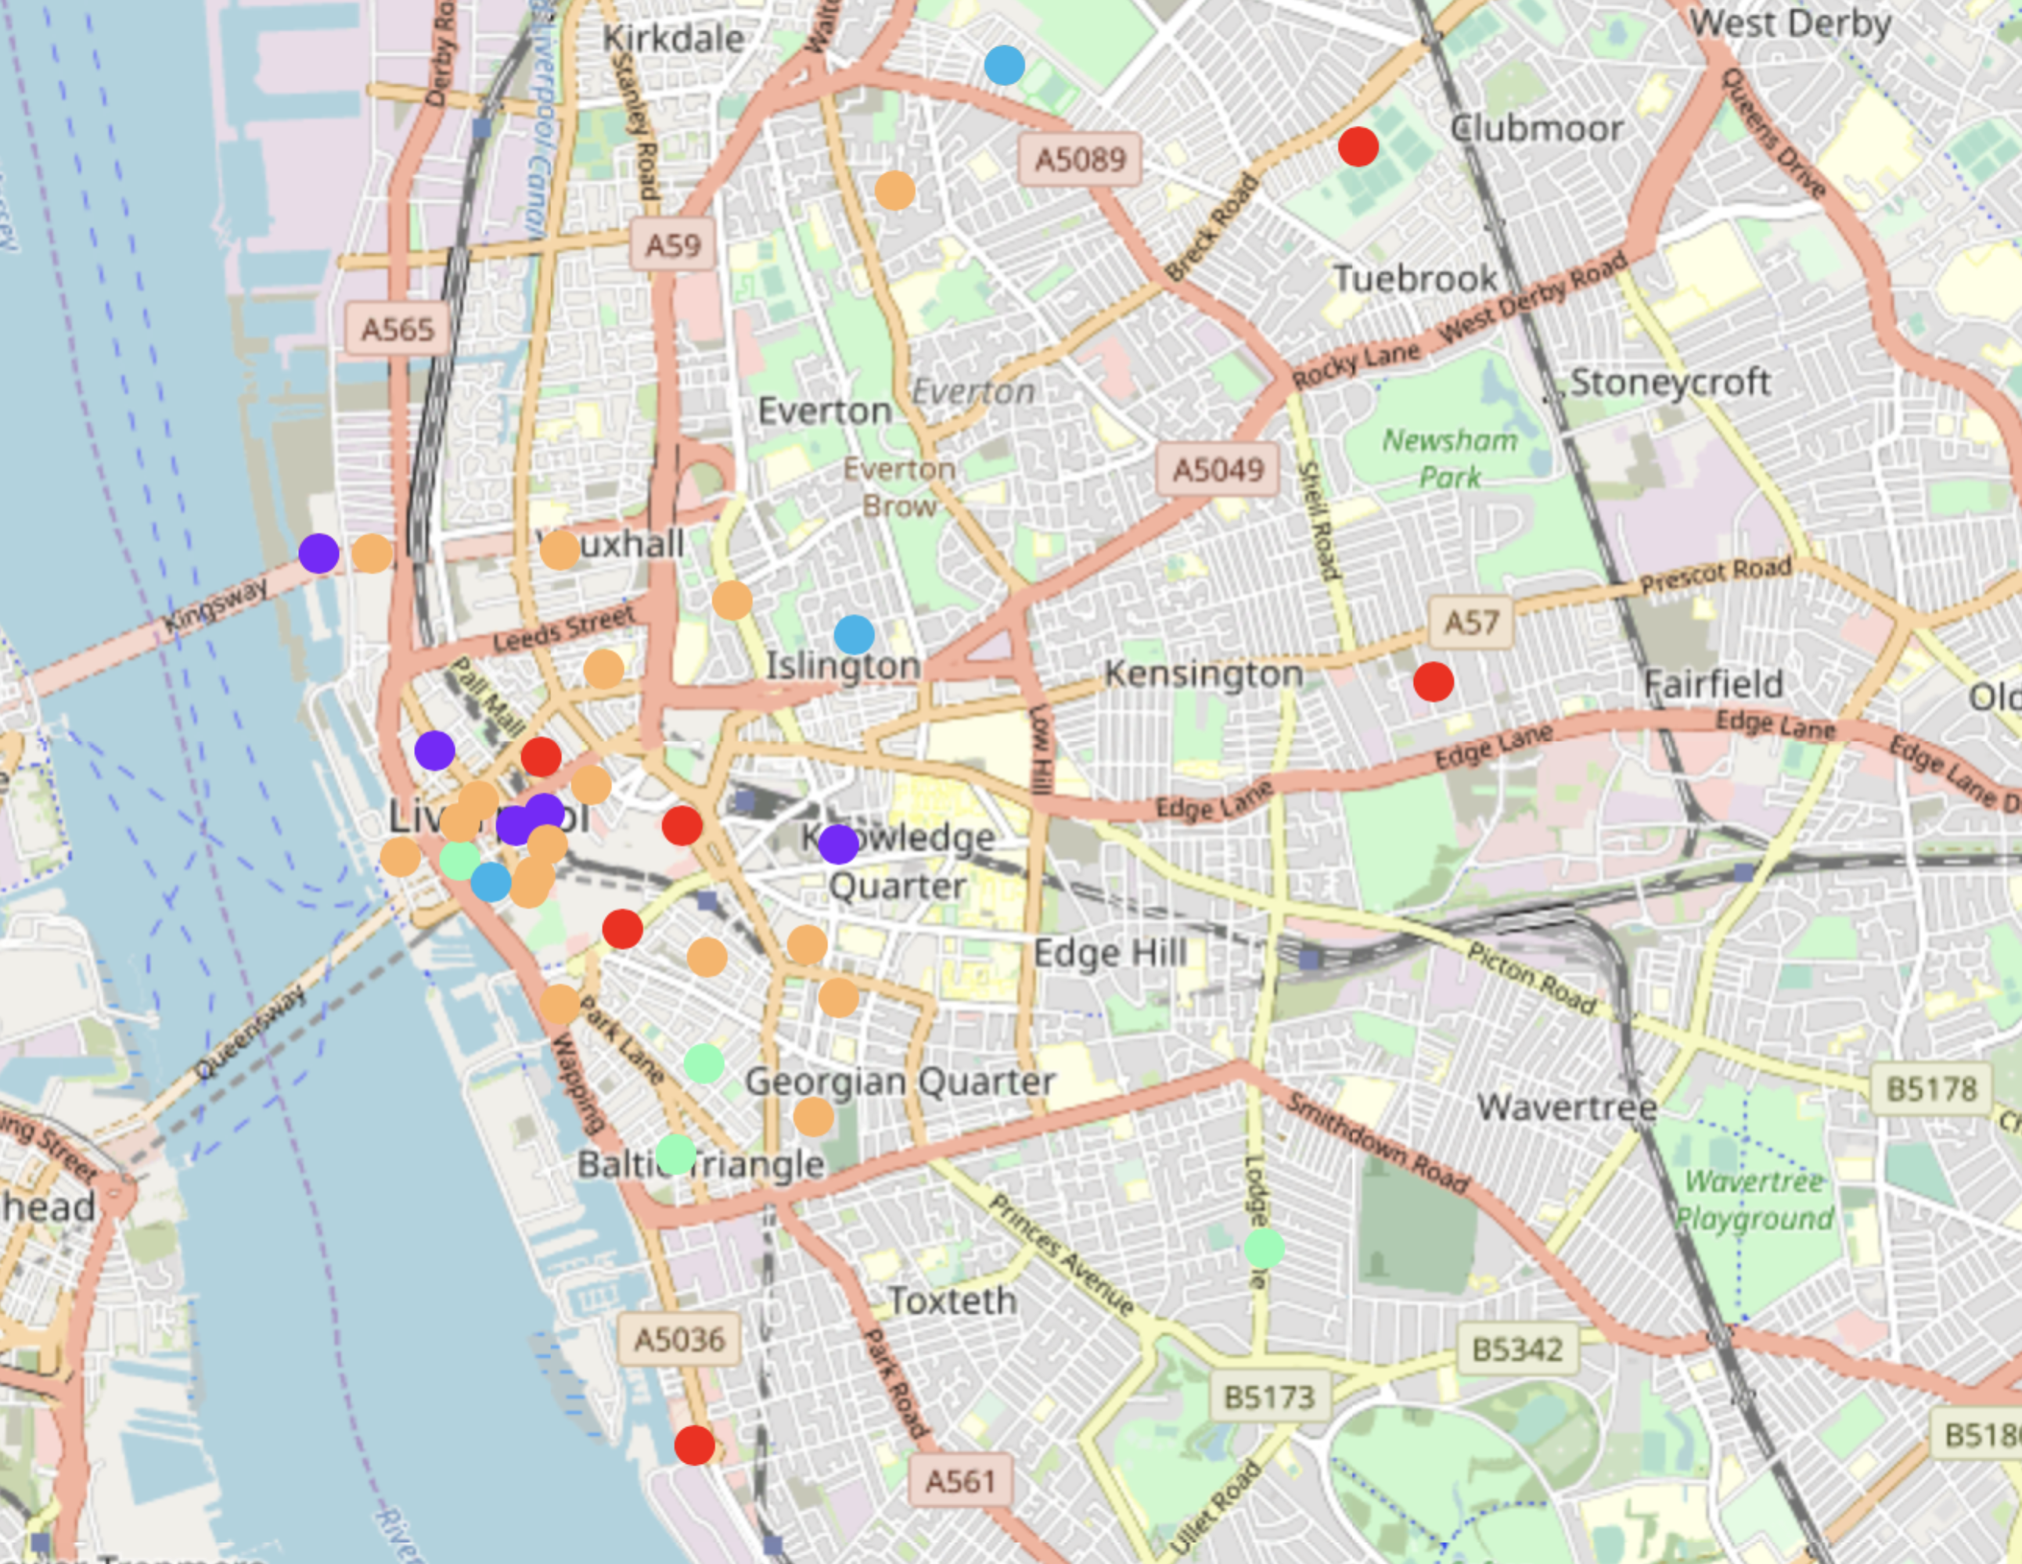

**Figure 8:** Map of Liverpool with color-coded markers depicting which cluster each neighborhood is grouped with.

Figure 8 shows a map of Liverpool with each neighborhood depicted by a circle marker. The markers are color-coded showing which cluster each neighborhood belongs to. The orange markers are cluster Zero which are mainly located in downtown Liverpool and closely surrounding neighborhoods. Clusters One and Two markers are red and purple respectively and are scattered around the map. Clusters Three and Four which appear in smaller numbers, are blue and green, and also located throughout the map of Liverpool.

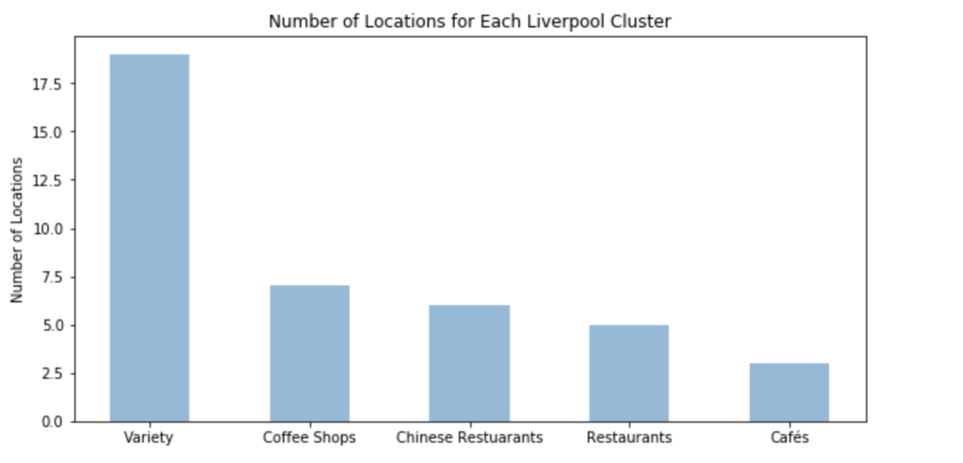

**Figure 9:** Bar graph depicting the number of Liverpool neighborhoods included in each cluster.

Cluster Zero, the variety cluster, includes the most Liverpool neighborhoods by far. Coffee shops and cafés , clusters one and two, contain approximately the same number of neighborhoods, with the last two clusters containing the least, which coincides with the Liverpool map.

**4.2. Manchester Results**

] 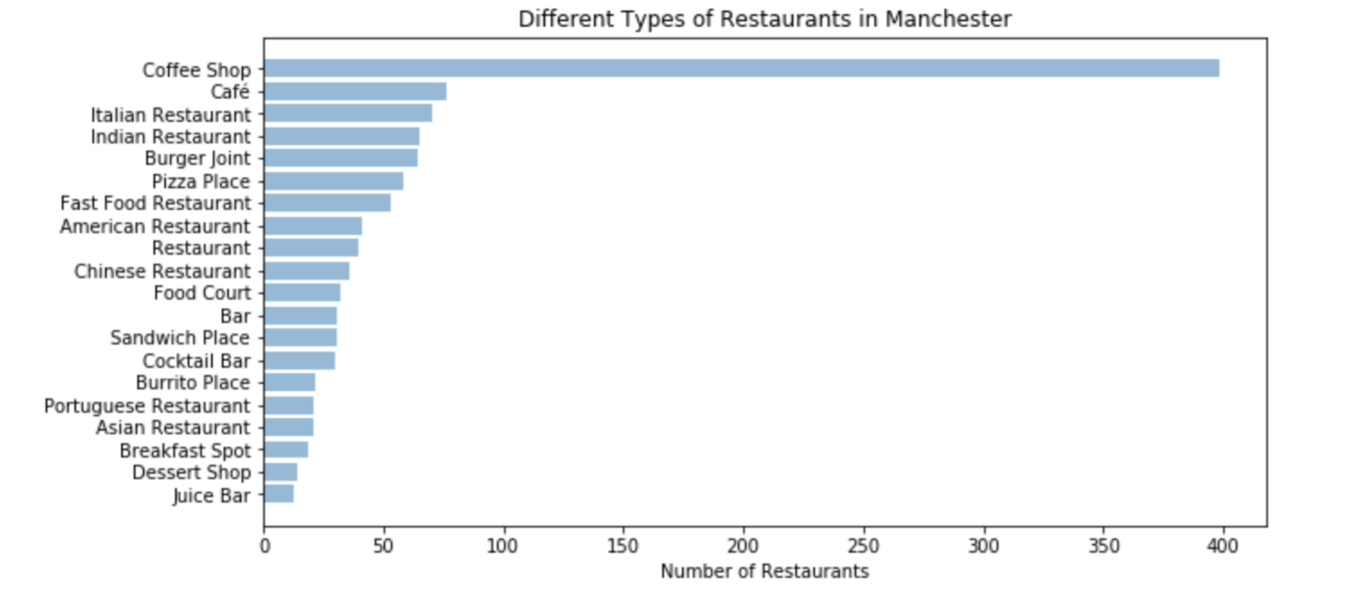

**Figure 10:** A graph depicting the variety of restaurants found in Manchester.

Coffee shops, café´s and Italian restaurants are the three top types of food venues in Manchester, with coffee shops by far having the largest number of venues. On the top twenty list there are six food venues with food from different parts of he world including Italian, Indian and Chinese restaurants.

After the Manchester data was clustered using k-mean clustering, four separate clusters were evaluated within Manchester. Cluster Zero was where the majority of restaurants offering food from a variety of cultures were located. Cluster One’s was where coffee shops and Vietnames restaurants were common, Cluster Two was Pizza, and Cluster Three was the American restaurant cluster.

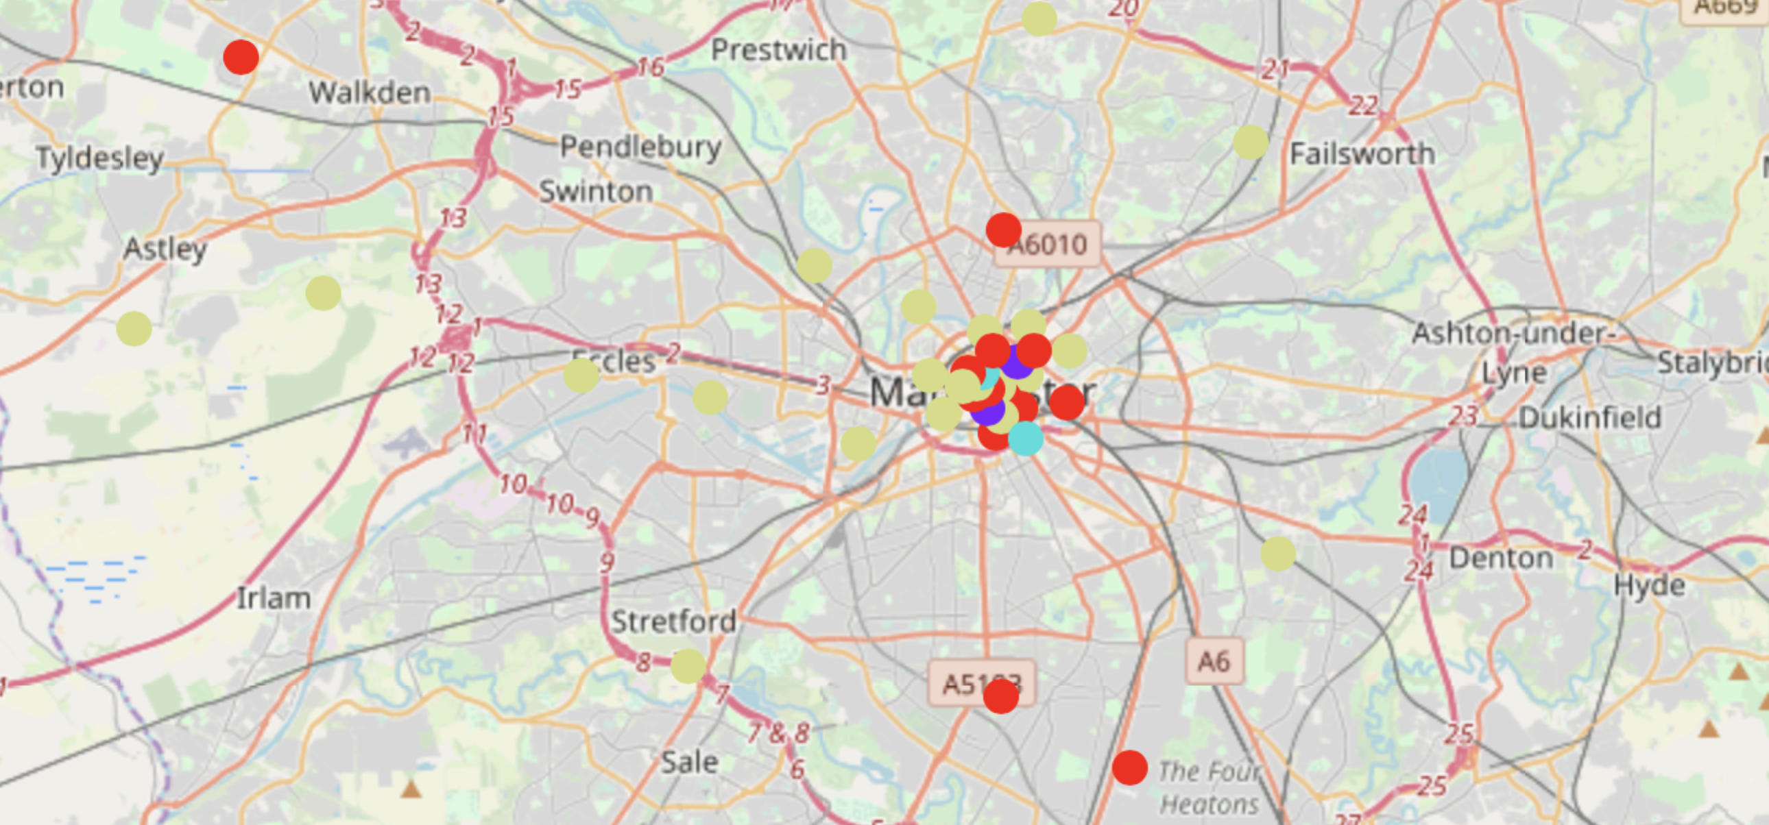

**Figure 11:** Map of Manchester with color-coded markers depicting which cluster each neighborhood is grouped with.

Figure 11 shows a map of Manchester with markers delineating where each neighborhood within Manchester is located. The color of each markers depicts which cluster the neighborhood belongs to. The green and red markers, cluster zero and cluster one respectively, are mainly located within downtown Manchester and surrounding neighborhoods. The purple and blue markers, cluster two and three, are low and number and scattered throughout Manchester.

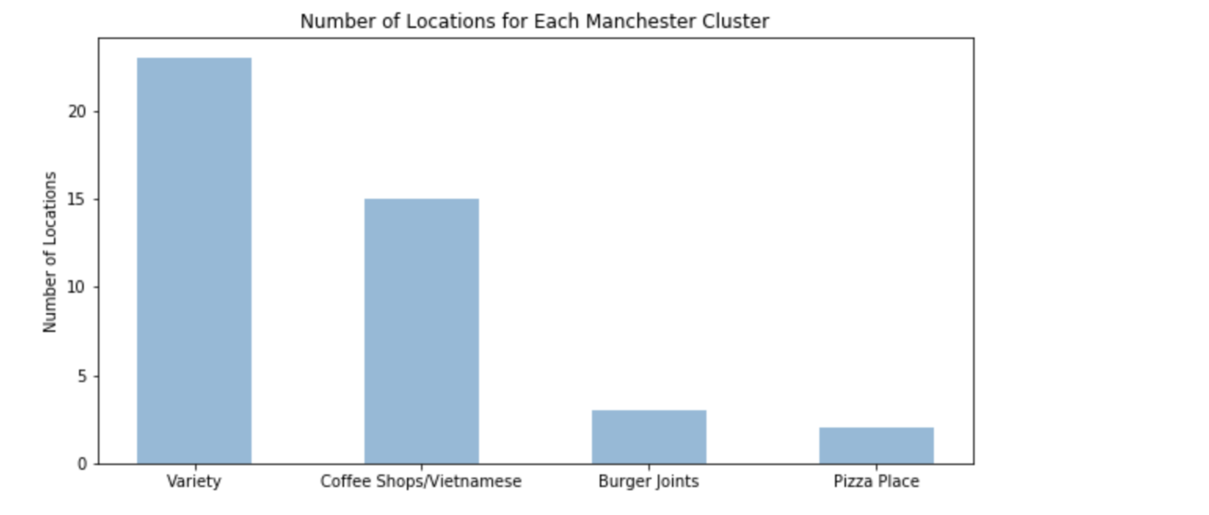

**Figure 12:** Bar graph depicting the number of Manchester neighborhoods included in each cluster.

As shown in Figure 12, the majority of neighborhoods are located in cluster zero, the variety cluster and cluster one, the coffee shop cluster.

**DISCUSSION**

When comparing the types of restaurants in both cities, Liverpool has more restaurants featuring cuisine from different places around the world in the top twenty food venues. Liverpool variety includes restaurants with cuisine from Italy, India, Asia, Portugal and the Middle East, though German restaurants do not make the top twenty. While Manchester also has some variety, the majority of their restaurants feature cuisine from different parts of the world are Italian and Indian, which are popular throughout the United Kingdom and Chinese.

Looking at the neighborhoods broken down into clusters, both contain clusters featuring coffee shops and/or cafés and a cluster containing a variety of restaurants. The clusters with neighborhoods featuring coffee shops and cafés in both cities, as expected, are scattered throughout the city and would not be the best place to open a German restaurant. For both cities, a German restaurant would fit in best in Cluster Zero, which is the cluster with a variety of restaurants. When looking at where the neighborhoods within cluster zero are located on the maps of their respective cities, the majority of Cluster Zero falls into the downtown area. Based on this, I would recommend that a German restaurant be open in Liverpool due to their variety of restaurants featuring world cuisine. The best neighborhood within Liverpool would be a cluster zero neighborhood located within the downtown area.

**CONCLUSION**

This study analyzed the best place to open a German restaurant when deciding between Liverpool and Manchester. Based on the analysis, the downtown Liverpool area would be the recommendation for opening this restaurant based on the variety of restaurants offered in Liverpool and where these restaurants are located. This analysis could also be helpful for determining a different type of restaurant to open and also for looking between other cities.

**REFERENCES**

1. <https://en.wikipedia.org/wiki/Liverpool>
2. <https://en.wikipedia.org/wiki/Manchester>
3. <https://en.wikipedia.org/wiki/L_postcode_area>
4. <https://en.wikipedia.org/wiki/M_postcode_area>